Practical Robotics Projects with Arduino
(CSE 4571)

Lab Assignment No – 08

Bluetooth Communication

Submission Date: _______________

Branch: CSE Section: 2241026
Name | Registration No. | Signature
Dinanath Dash | 2241004161

Department of Computer Science and Engineering
Institute of Technical Education and Research (Faculty of Engineering)
Siksha 'O' Anusandhan (Deemed to be University)
Bhubaneswar, Odisha-751030.

Aim:
To interface an HC-05/HC-06 Bluetooth module with Arduino UNO for wireless serial communication between the Arduino and a Bluetooth-enabled device.
Objectives:
- To gain familiarity with the HC-05/HC-06 module and Arduino UNO serial communication.
- Learn the pin configuration (VCC, GND, TXD, RXD, EN/KEY) of the HC-05/HC-06 module.
- Understand the role of baud rate, pairing code, and serial communication protocol.
- To establish a basic wireless link between Arduino UNO and a smartphone/PC.
- Connect the HC-05/HC-06 module to the Arduino UNO (using SoftwareSerial).
- Write a simple Arduino sketch to send and receive data over Bluetooth.
- Pair the module with a smartphone/PC using a Bluetooth terminal app and verify successful two-way communication.
- To implement bidirectional communication and LED control.
- Build an external circuit with an LED connected to Arduino digital pin 6.
- Modify the Arduino program to turn the LED ON when the smartphone sends the character 1, and OFF when it sends 0.
- Send acknowledgment messages back to the smartphone (e.g., “LED ON” / “LED OFF”).
- To Evaluate communication performance.
- Test and record the effective communication range of the Bluetooth module.
- Measure response latency between sending a command (from phone) and Arduino execution.

Pre-Lab Questionnaire:
- Name all the pins of the HC-05/HC-06 module and their functions.
- Why is a voltage divider required between Arduino TX and HC RX?
- What is the default baud rate of the HC-05/HC-06 module?
- Explain the difference between HC-05 and HC-06 modules.
- What is Software Serial in Arduino, and why is it used in this experiment?
- What is the purpose of pairing a Bluetooth device before communication?
- How does Arduino interpret commands sent from a smartphone?
- How can you verify if the HC-05/HC-06 module is powered and ready for pairing?
- List the factors that can affect Bluetooth communication range.
- Explain the role of the Serial Monitor in this experiment.
Answers to Pre-Lab Questions

Components/Equipment Required:
Sl. No. | Name of the Component / Equipment | Specification | Quantity
1) | Arduino UNO R3 | 16MHz | 1
2) | Arduino UNO cable | USB Type A to Micro-B | 1
3) | HC-05 / HC-06 Bluetooth Module | Bluetooth 2.0 SPP, 3.3V TTL logic, default baud rate 9600 bps | 1
4) | Resistors (carbon type) | 220Ω / 2.2kΩ/ 1 kΩ | 1 each
5) | LED | Any colour of your choice | 1
6) | Breadboard | 840 Tie points | 1
7) | Smartphone with Bluetooth / PC with Bluetooth | Android/iOS device or Windows PC, for testing wireless serial communication | 1
8) | Bluetooth Terminal App | Android/iOS app like “Serial Bluetooth Terminal” or “Bluetooth Terminal | 1
9) | Jumper Wire | --------------------------- | As per requirement

Objective 1
To Gain familiarity with the HC-05/HC-06 module and Arduino UNO serial.

Circuit / Schematic Diagram
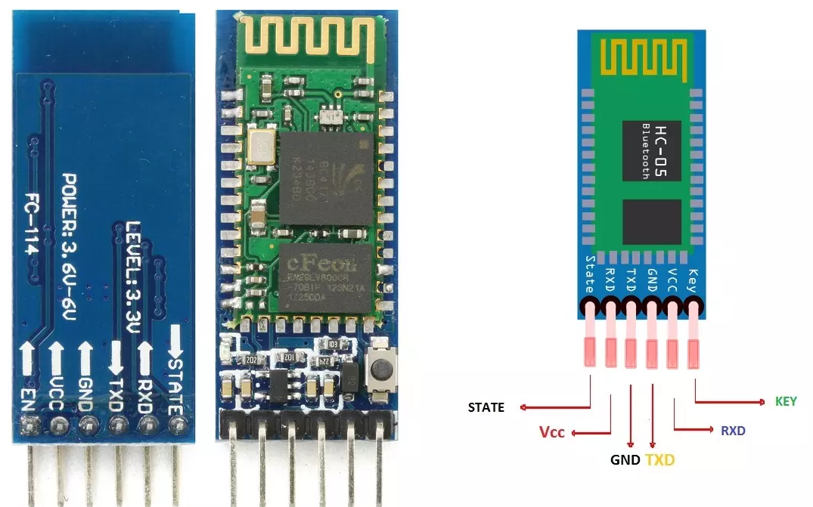
Figure 1: HC-05/HC-06 module Pinout
Observation
(Write how you have done the connection between the Bluetooth module and Arduino uno)

Objective 2
To establish a basic wireless link between Arduino UNO and a smartphone/PC.

Circuit / Schematic Diagram
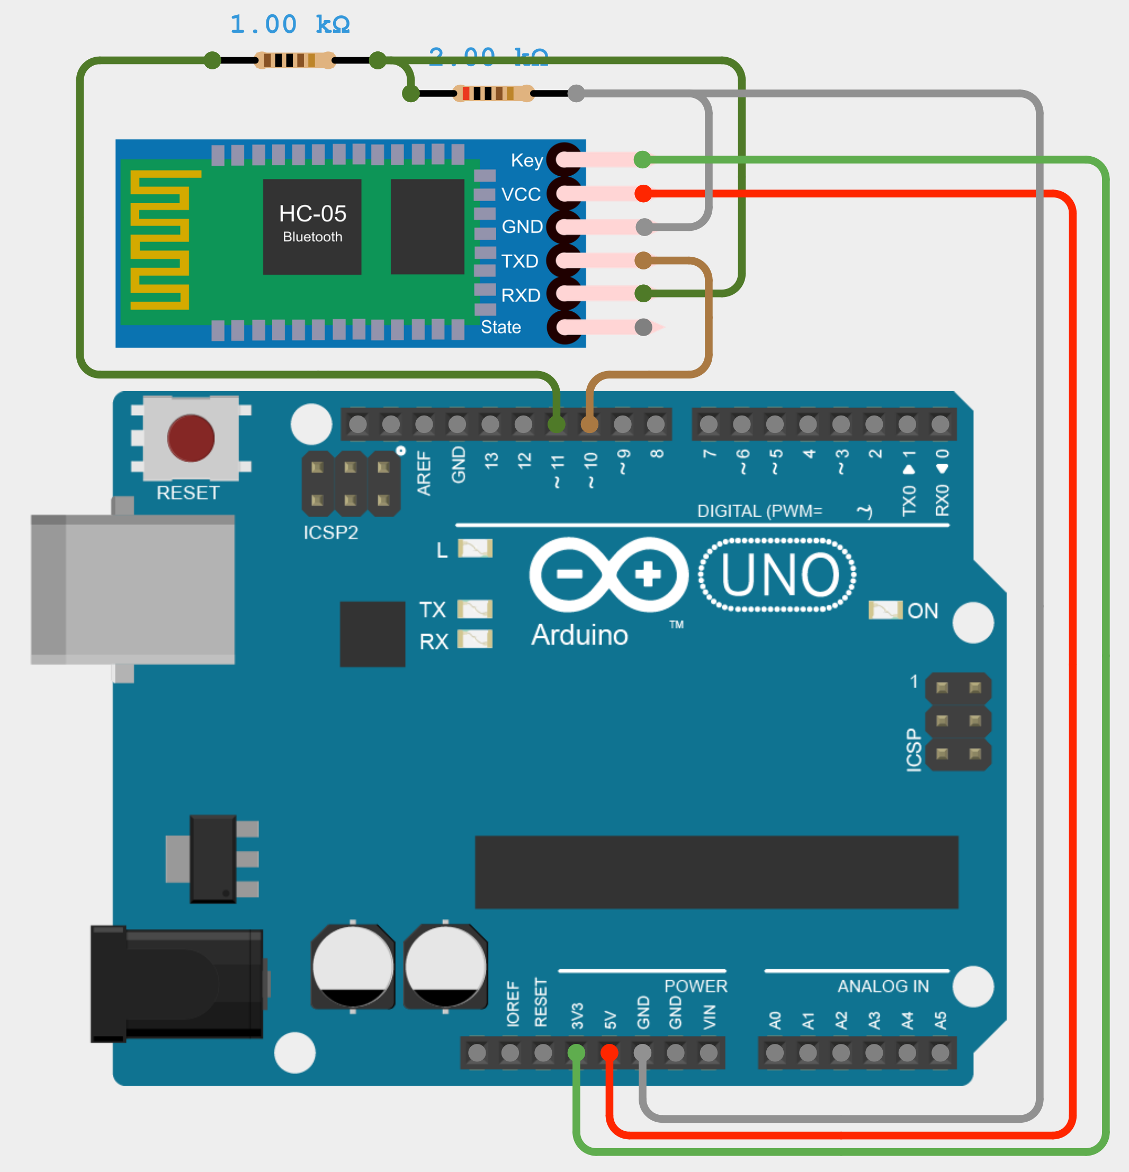
Figure 2: Interface between Arduino UNO and HC-05/HC-06 module
Code

#include <SoftwareSerial.h>
SoftwareSerial BT(10, 11); // RX, TX
void setup() {
Serial.begin(9600);
BT.begin(9600);
Serial.println("Ready to communicate. Type on Serial Monitor or Bluetooth app.");
}
void loop() {
if (Serial.available()) {
char data = Serial.read();
BT.write(data);
}
if (BT.available()) {
char data = BT.read();
Serial.write(data);
}
}

Observation

Figure 3: Interface of Arduino UNO with HC-05/HC-06 module
Figure 4: Interface of Arduino UNO with HC-05/HC-06 module (Hardware)
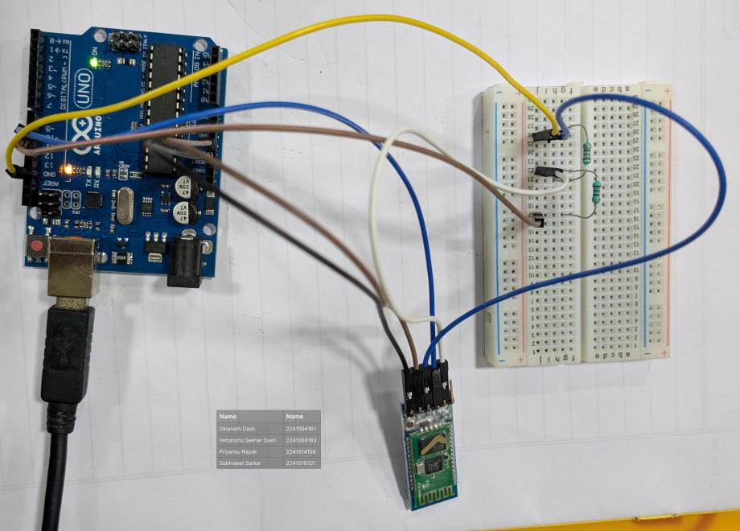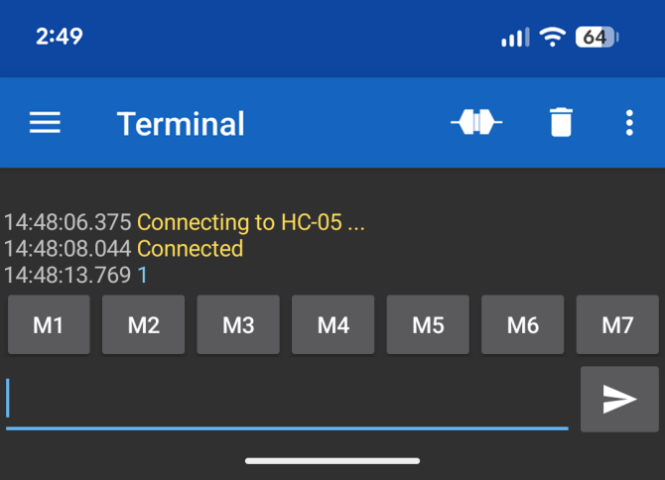
Objective 3
To implement bidirectional communication and LED control.

Circuit / Schematic Diagram
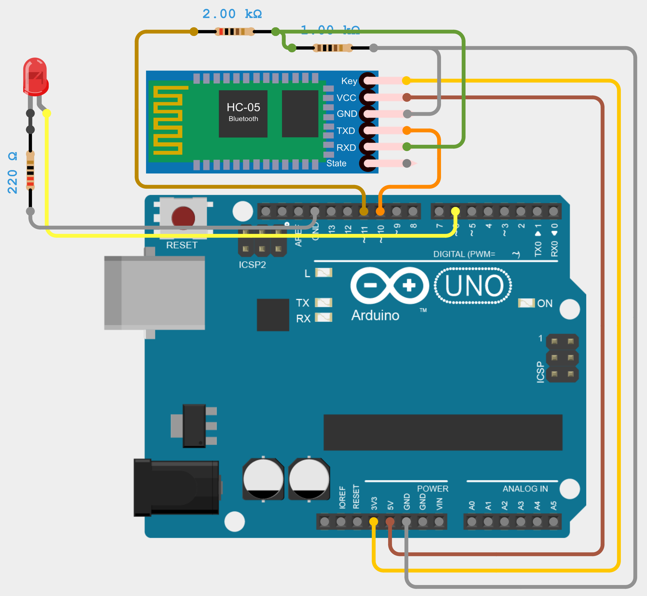
Figure 5: Interface between Arduino UNO and HC-05/HC-06 module
Code
#include <SoftwareSerial.h>
SoftwareSerial BT(10, 11); // RX, TX
int led = 6;
void setup() {
pinMode(led, OUTPUT);
Serial.begin(9600);
BT.begin(9600);
Serial.println("Send '1' to turn ON LED, '0' to turn OFF.");
}
void loop() {
if (BT.available()) {
char cmd = BT.read();
Serial.print("Received: ");
Serial.println(cmd);

if (cmd == '1') {
digitalWrite(led, HIGH);
BT.println("LED ON");
Serial.println("LED turned ON");
}
else if (cmd == '0') {
digitalWrite(led, LOW);
BT.println("LED OFF");
Serial.println("LED turned OFF");
}
else {
BT.println("Invalid Command");
}
}
}
Observation

Figure 6: Interface HC-06 and Arduino UNO for bidirectional communication and LED control and confirmation in serial monitor window
Figure 7: Interface HC-06 and Arduino UNO for bidirectional communication and LED control and confirmation in serial monitor window (Hardware)
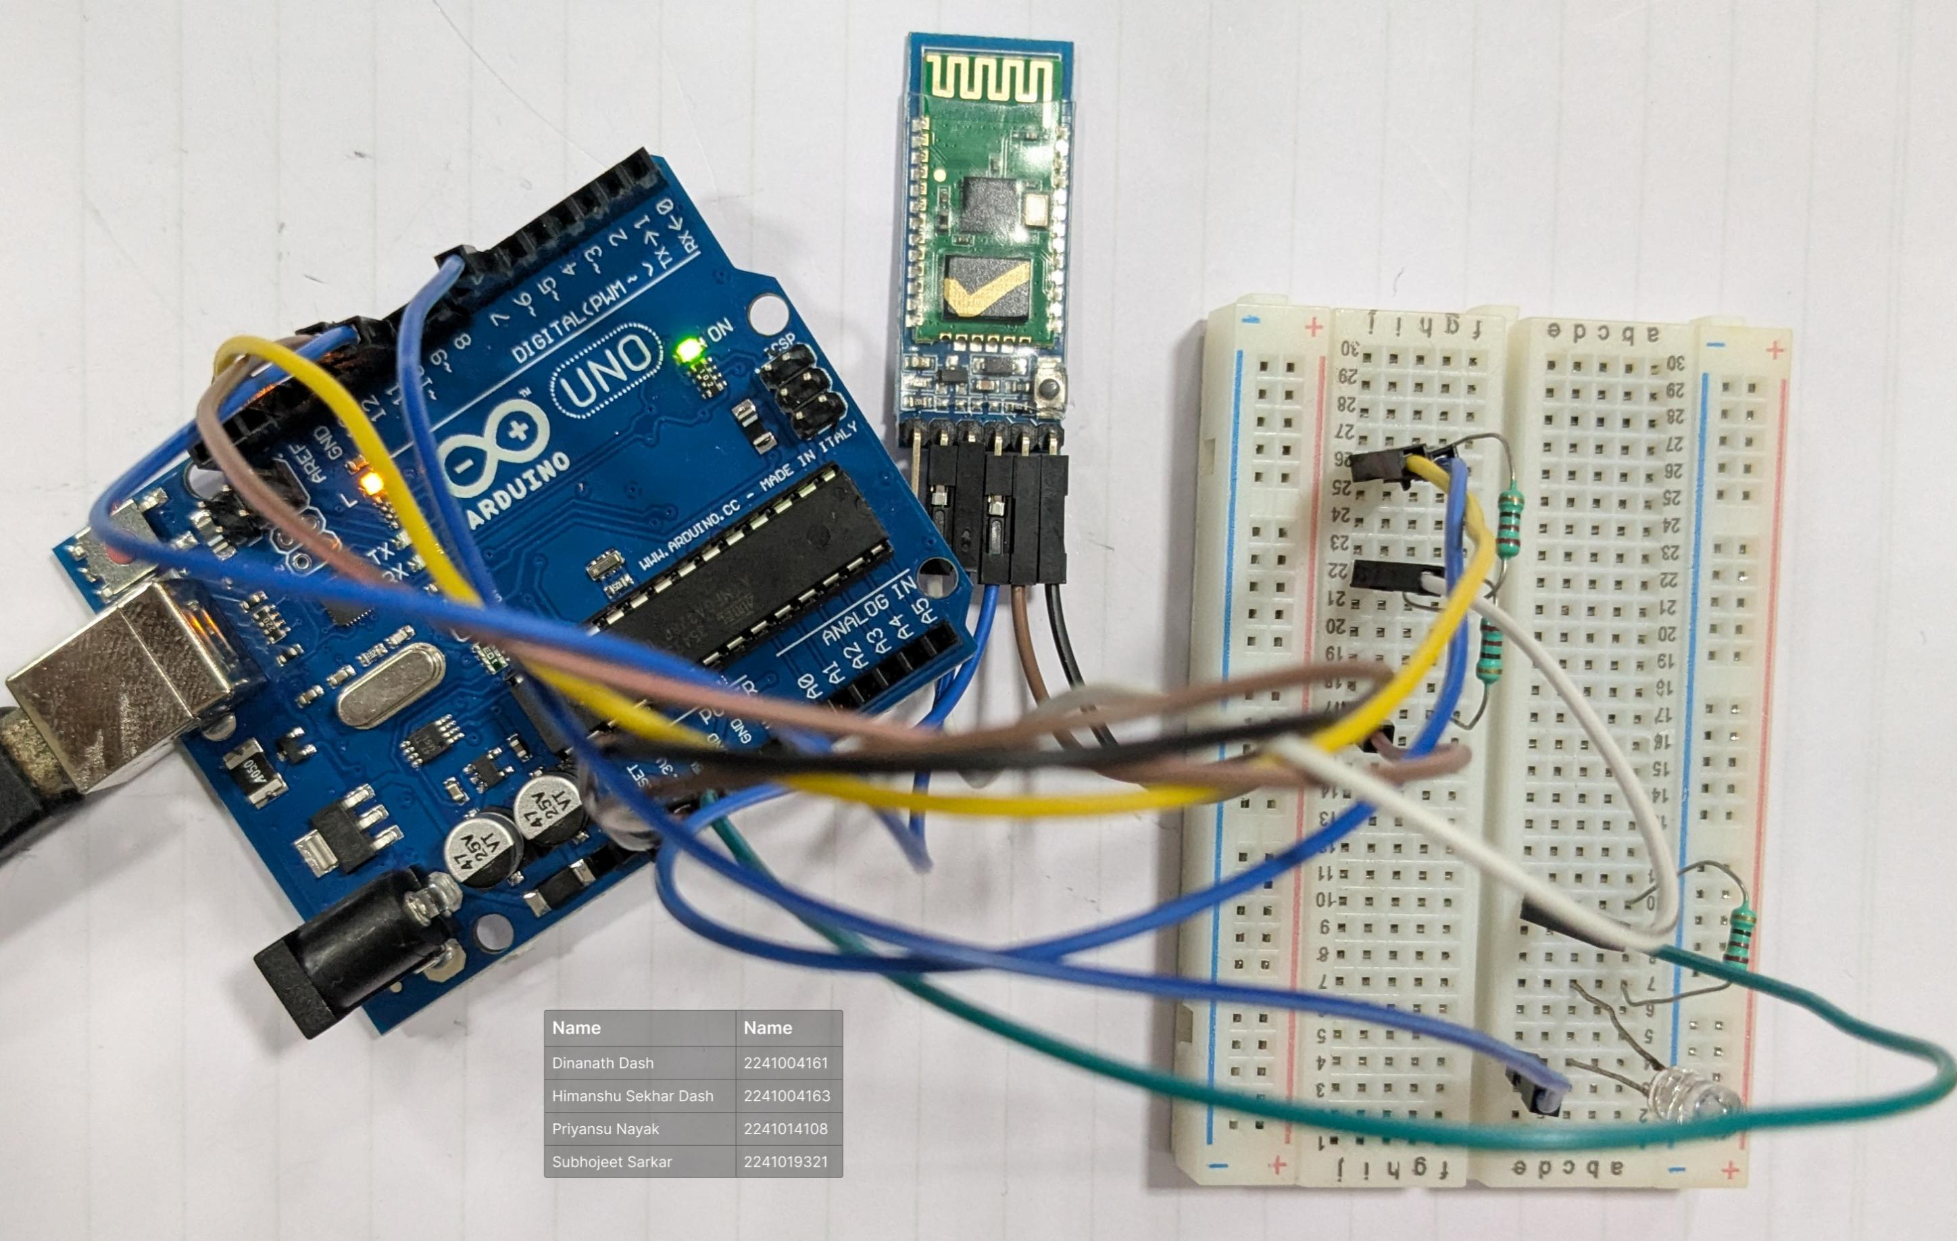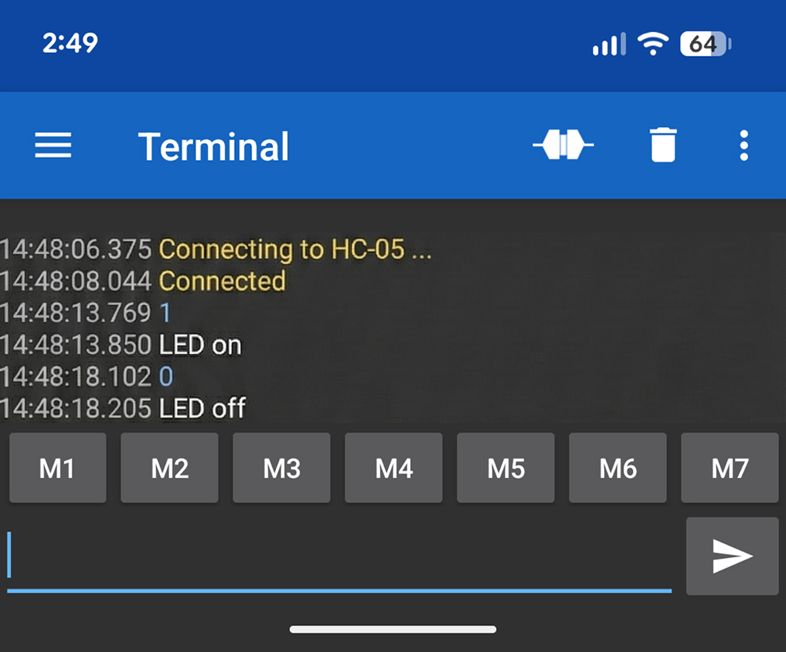
Objective 4
To Evaluate communication performance.

Circuit / Schematic Diagram
Figure 8: Establish connection with the Serial Monitor and Mobile Phone
Code
#include <SoftwareSerial.h>
SoftwareSerial BT(10, 11); // RX, TX
int led = 6;
void setup() {
pinMode(led, OUTPUT);
Serial.begin(9600);
BT.begin(9600);
Serial.println("Send '1' to turn ON LED, '0' to turn OFF.");
}
void loop() {
if (BT.available()) {
char cmd = BT.read();
Serial.print("Received: ");
Serial.println(cmd);

if (cmd == '1') {
digitalWrite(led, HIGH);
BT.println("LED ON");
Serial.println("LED turned ON");
}
else if (cmd == '0') {
digitalWrite(led, LOW);
BT.println("LED OFF");
Serial.println("LED turned OFF");
}
else {
BT.println("Invalid Command");
}
}
}
Observation

Figure 9: Test, record and Measure response latency (Hardware)
Conclusion

Precautions

Post Experiment Questionnaire:
- How did you establish bidirectional communication between Arduino and a smartphone?
- Describe the steps to control an LED using Bluetooth commands.
- What was the maximum reliable communication range achieved during the experiment?
- How did you implement forwarding between Serial Monitor and Bluetooth?
- What challenges did you face while pairing the HC-05/HC-06 module?
- Explain how the Arduino code processes different commands (1 = ON, 0 = OFF).
- How would you modify the setup to control multiple LEDs with different commands?
- Compare the observed LED behavior when using Serial Monitor vs. smartphone commands.

Answers to Post-Lab Questions

(Signature of the Faculty) | (Signature of the Student)
 | Name:
Date: | Registration No.:
 | Branch:
 | Section

